Software Architecture Description v1.0
Kamil Moralewski
CEIS400— Team 4
Date: 2024/01/20

Contents
1. Software Architecture Description Summary 4
2. Static View 5
3. Dynamic View 8
4. Revisions 11

Software Architecture Description Summary
Supported Architectural Styles:
- Object-Oriented: Each class will include objects that will interact with one another to handle different data and behaviors.
- Layered: All modules will have their place in the organized structure to make maintenance easier.

Supported Quality Attributes:

- Efficiency: Supported by using resources wisely and maximizing power without increasing expenses.
- Maintainability: Supported through ongoing update and maintenance to all components of the system.
- Performance: Supported through the methods used to handle and organize data following SRS.
- Reliability: Supported by keeping things organized and making sure each part of the system is functioning properly.
- Scalability: Supported by adding new features or datasets to grow the system.
- Security: Supported through the methods used to protect and control access to the system and its sensitive components.
- Supportability: Supported by having a support team to help with troubleshooting and support.
- Usability: Supported through the implementation of a user-friendly interface that users will enjoy.

Static View
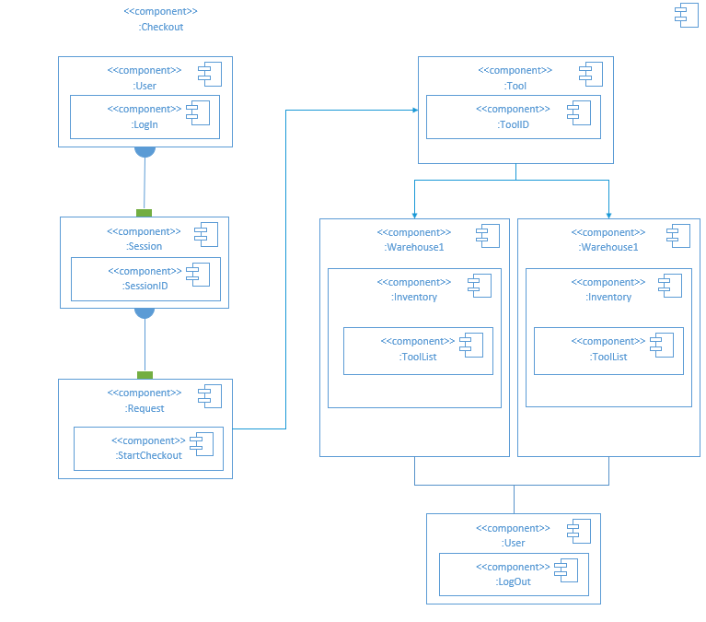
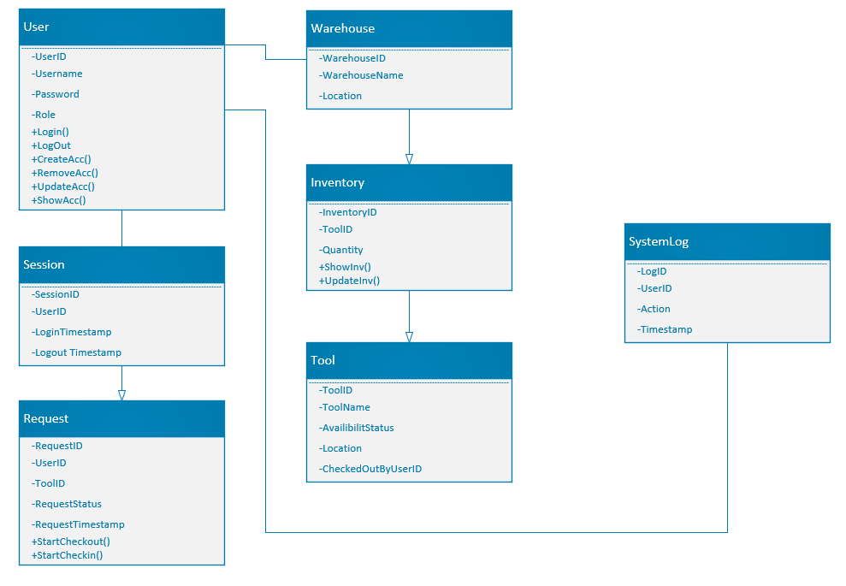

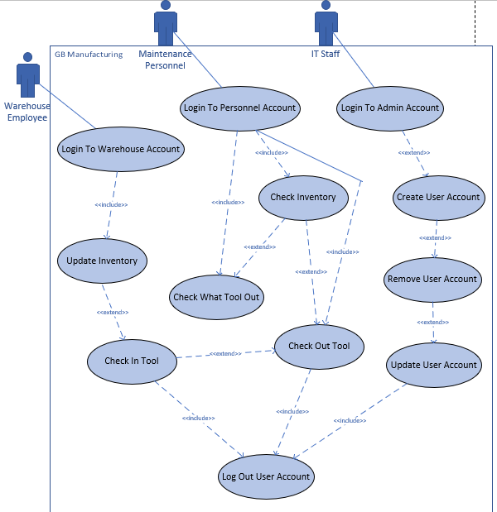

Dynamic View
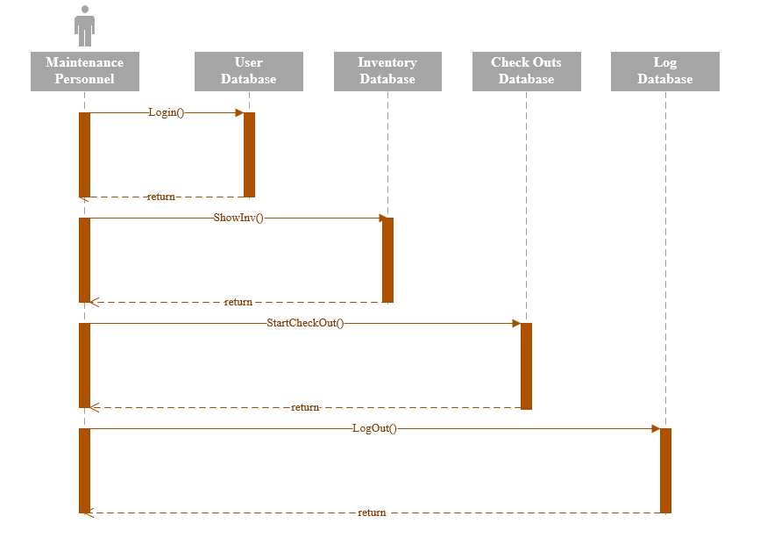
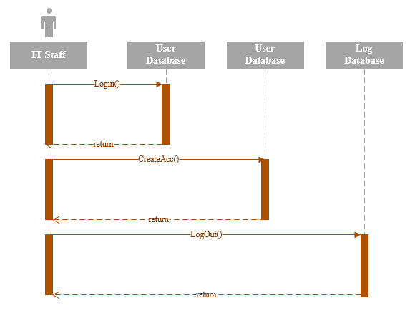

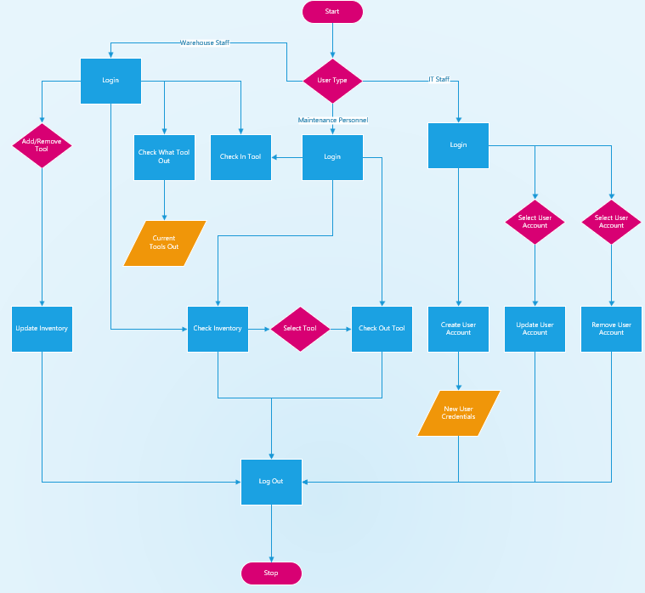

Revisions

Date | Revision | Description | Author
01/20/2024 | 1.0 | Created Software Architecture Description | Kamil Moralewski

